What you’ll need to do ahead of time:
Using a hand trowel dig a hole about 6-8 inches deep. You will want to take a several tablespoons of soil from the bottom of the hole. You want enough soil to form a ball about 2-3 in in diameter. If you have a pH meter, use it in the hole you have dug and record the measurement.
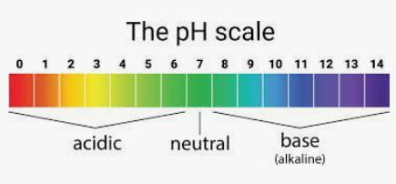
Place your soil sample into a small container with a lid. You can keep it moist by placing a damp towel on top if it. You will want the soil to be a little damp when we start the lab.
Make note of any history of which you are aware for the property, and any features you can see:
What is the topography of the site (flat, hilly etc.)?
What is the vegetation cover - is this a treed area, grassy or is it mostly exposed soil?
Do you know anything about the history of the area?
Is there any current activity in close proximity that might impact your site (i.e., construction)?
Can you see any evidence of the geology (rocks lying on the surface, or an outcrop)?
Is there any evidence of erosion occurring?
For the lab itself:
You will need to have some water with you, you can use a water bottle or spray bottle, and place your soil sample into a container large enough to let you get your hands in it.
I will be walking everyone through the texturing and ribboning of the soil during the lab.
You will use the diagrams below (along with pH if you measured it) to try and determine what kind of soil you have.
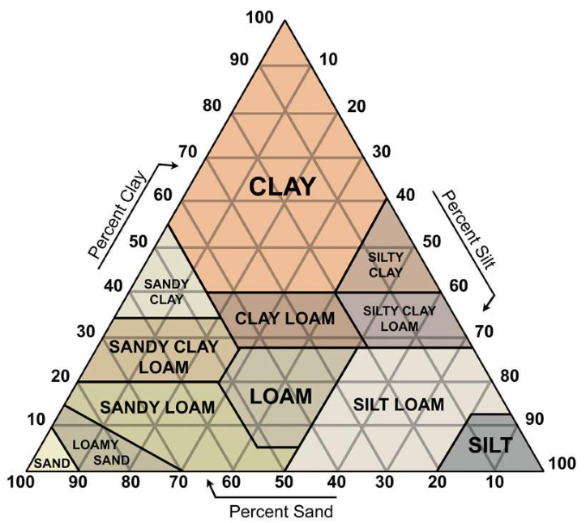

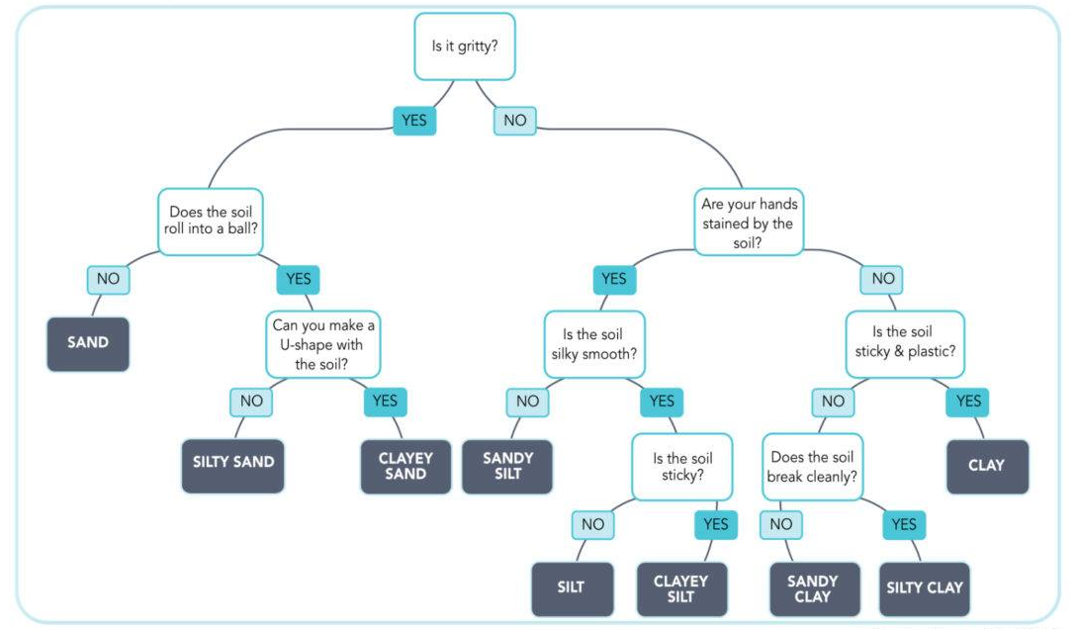
Now go to the Web Soil Survey site: http://websoilsurvey.sc.egov.usda.gov/App/HomePage.htm
You can enter the address of your site, then outline an Area Of Interest (AOI) around your specific location to get your answer (note that your results on WSS will be in soil suborders, so you may have to look it up to find if it is a vertisol, mollisol etc.).
Any surprises? Did your scientific guess come close to what WSS tells you? What do you think led you to a correct or incorrect identification?
If you would like to have your soil tested at a lab, take a look at the Texas A&M site: Texas A&M AgriLife Extension Service Soil, Water and Forage Testing Laboratory (tamu.edu)

